Grouping Territories

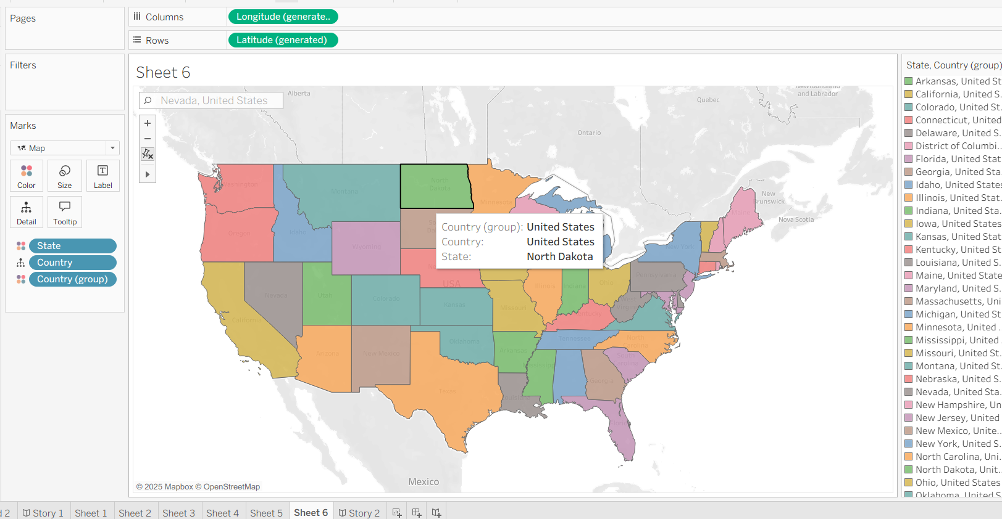

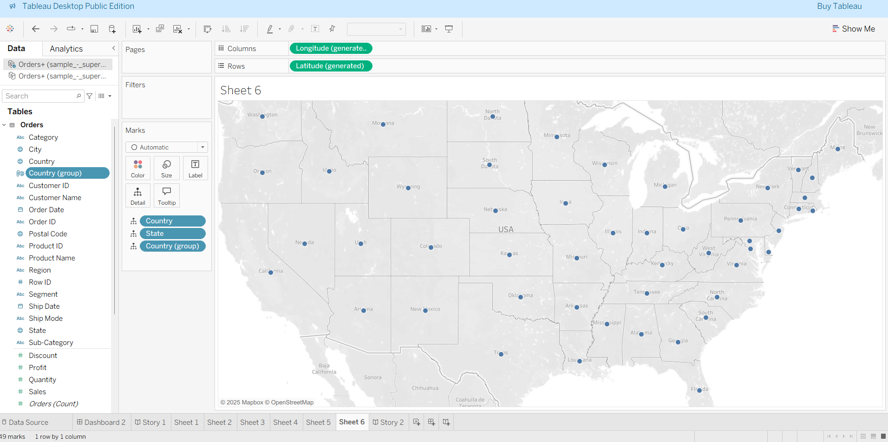

**Building a Choropleth Map and Custom Territories in Tableau**

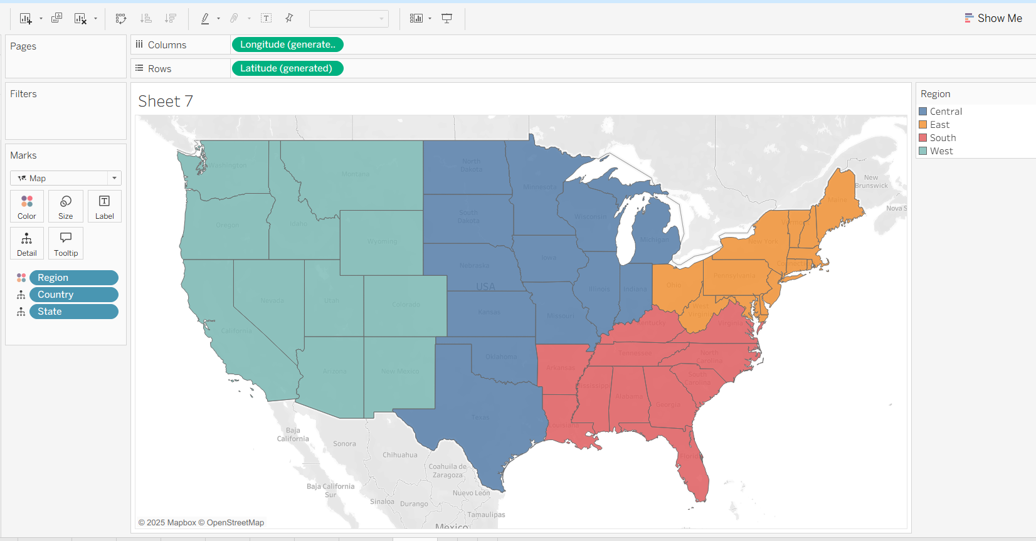

Adding SALES to it

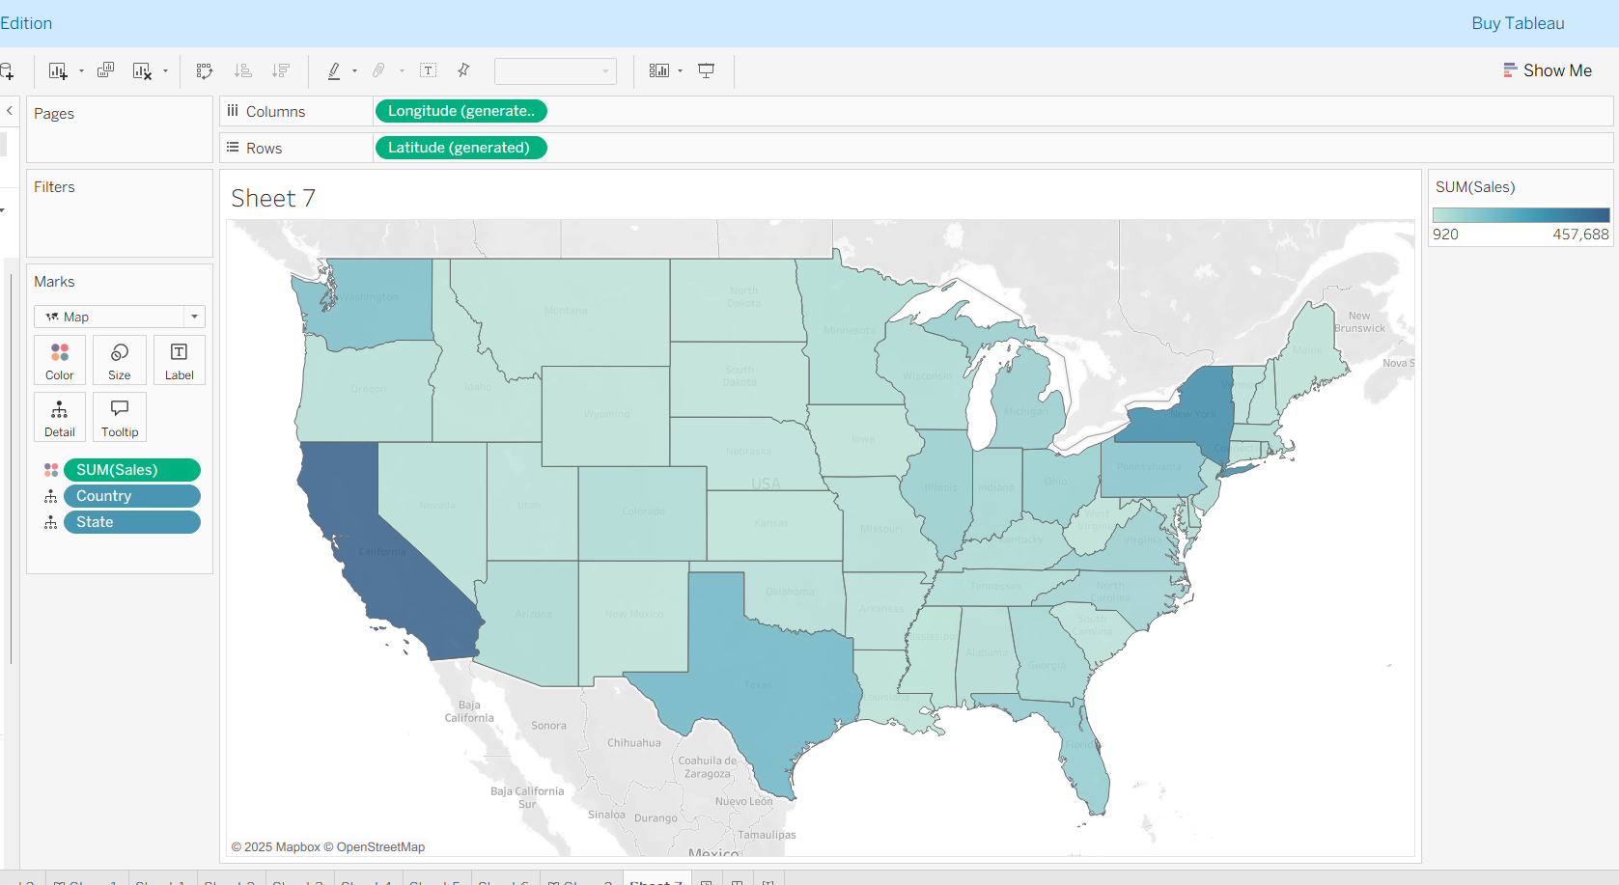

Adding PROFIT

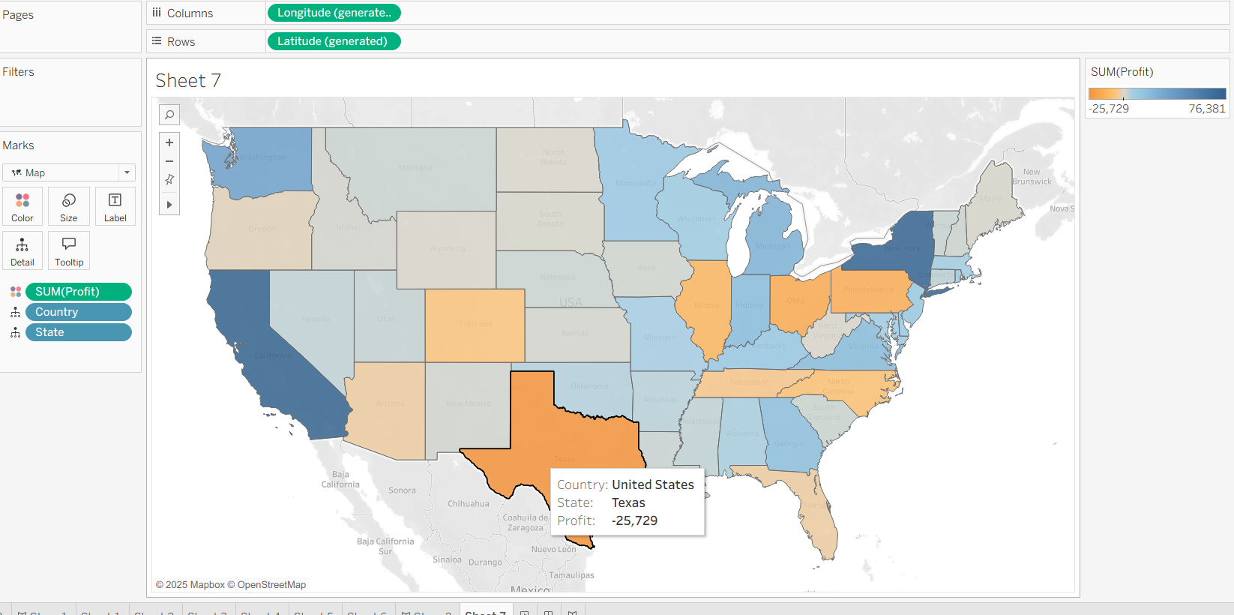

Adding custom REGION

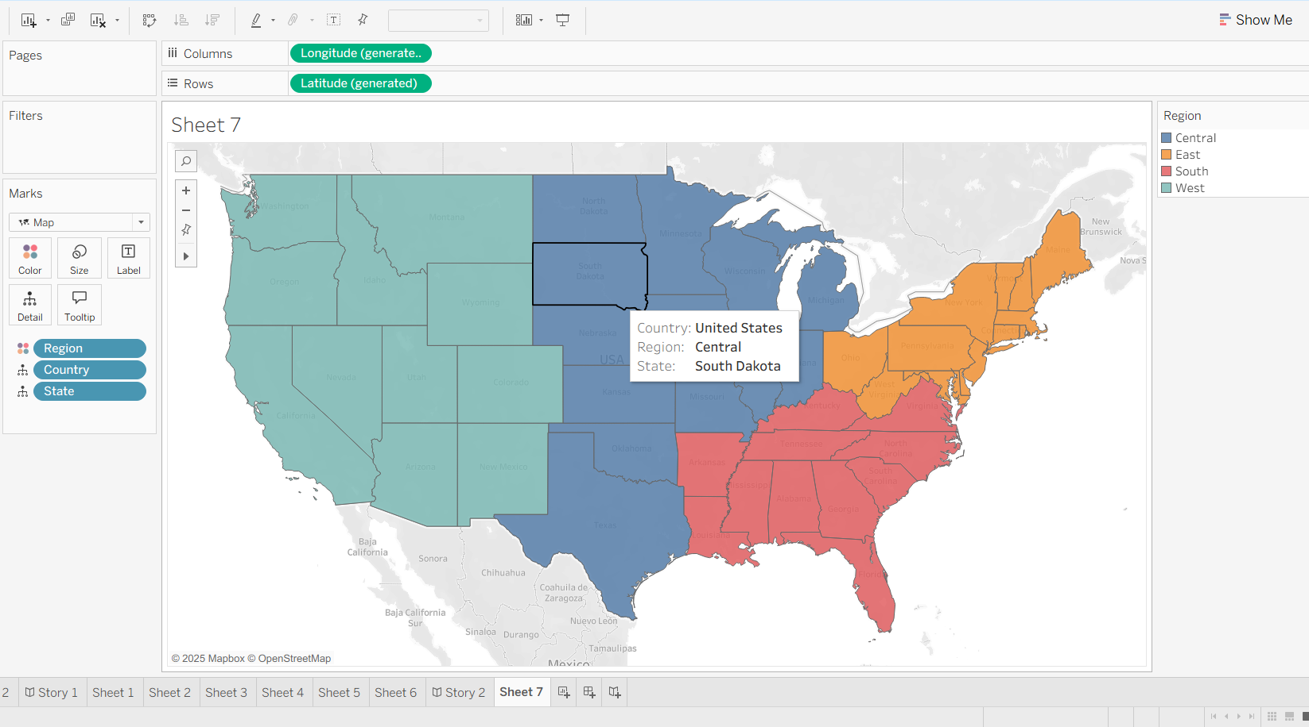

Group by STATE (Individualy)

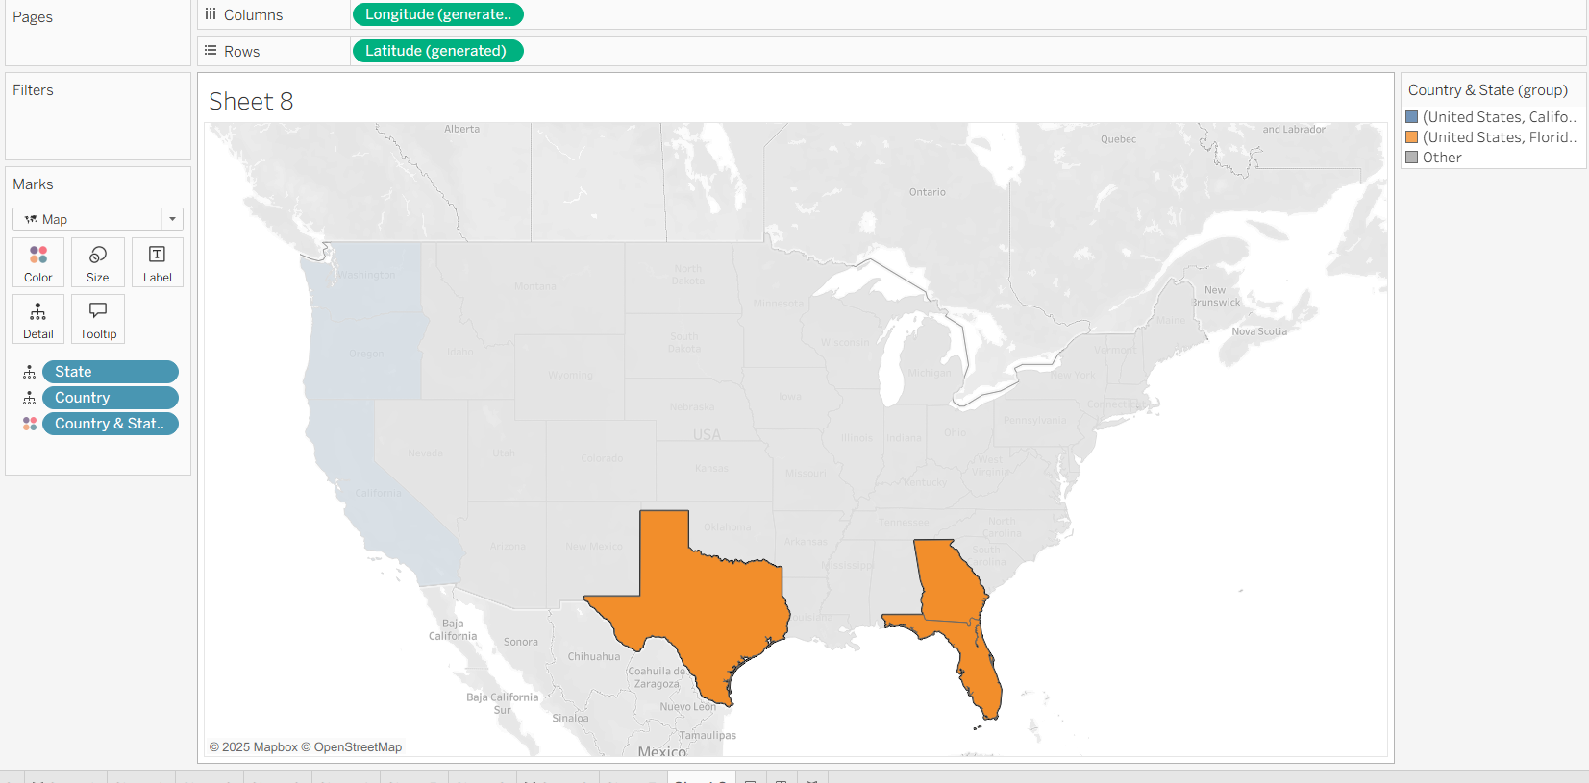

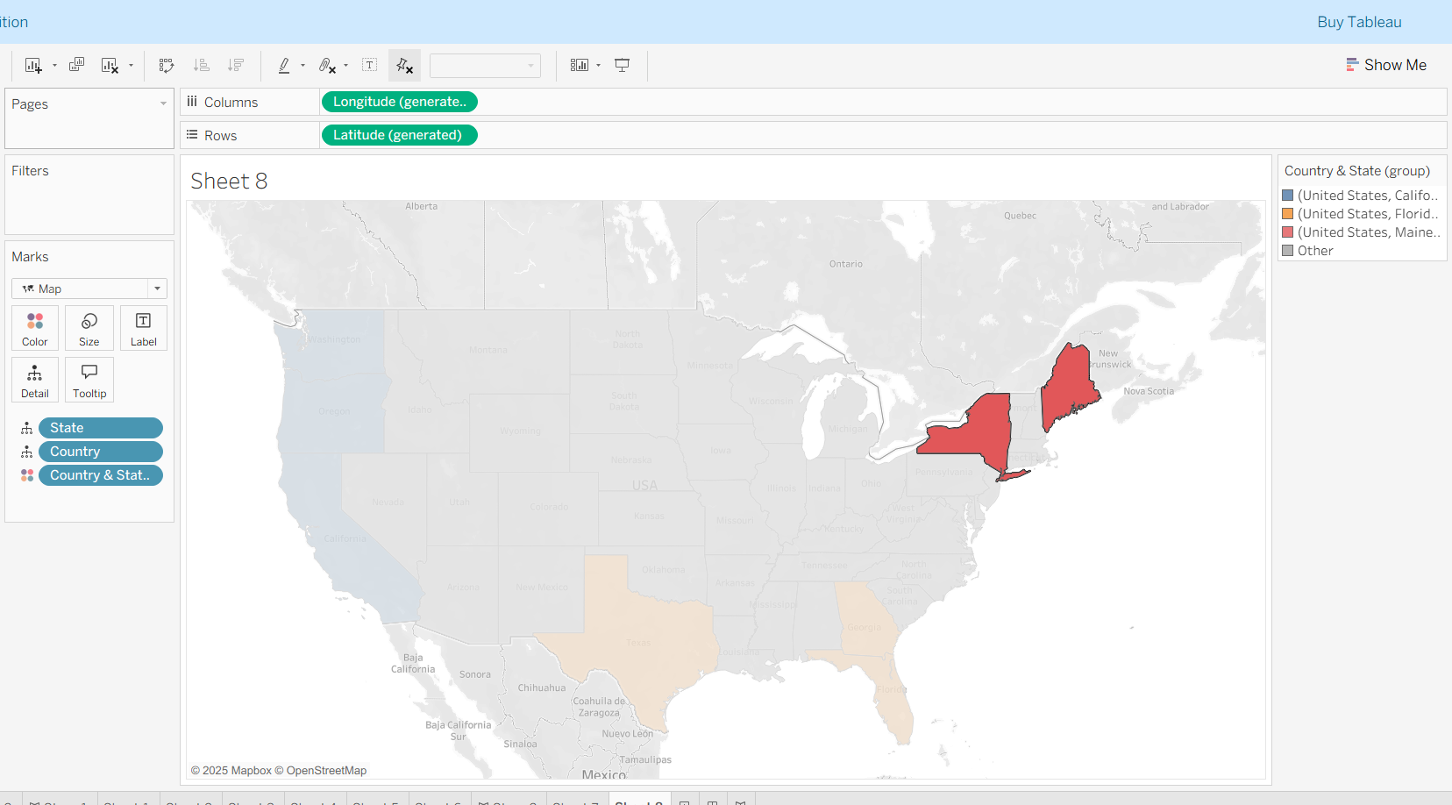

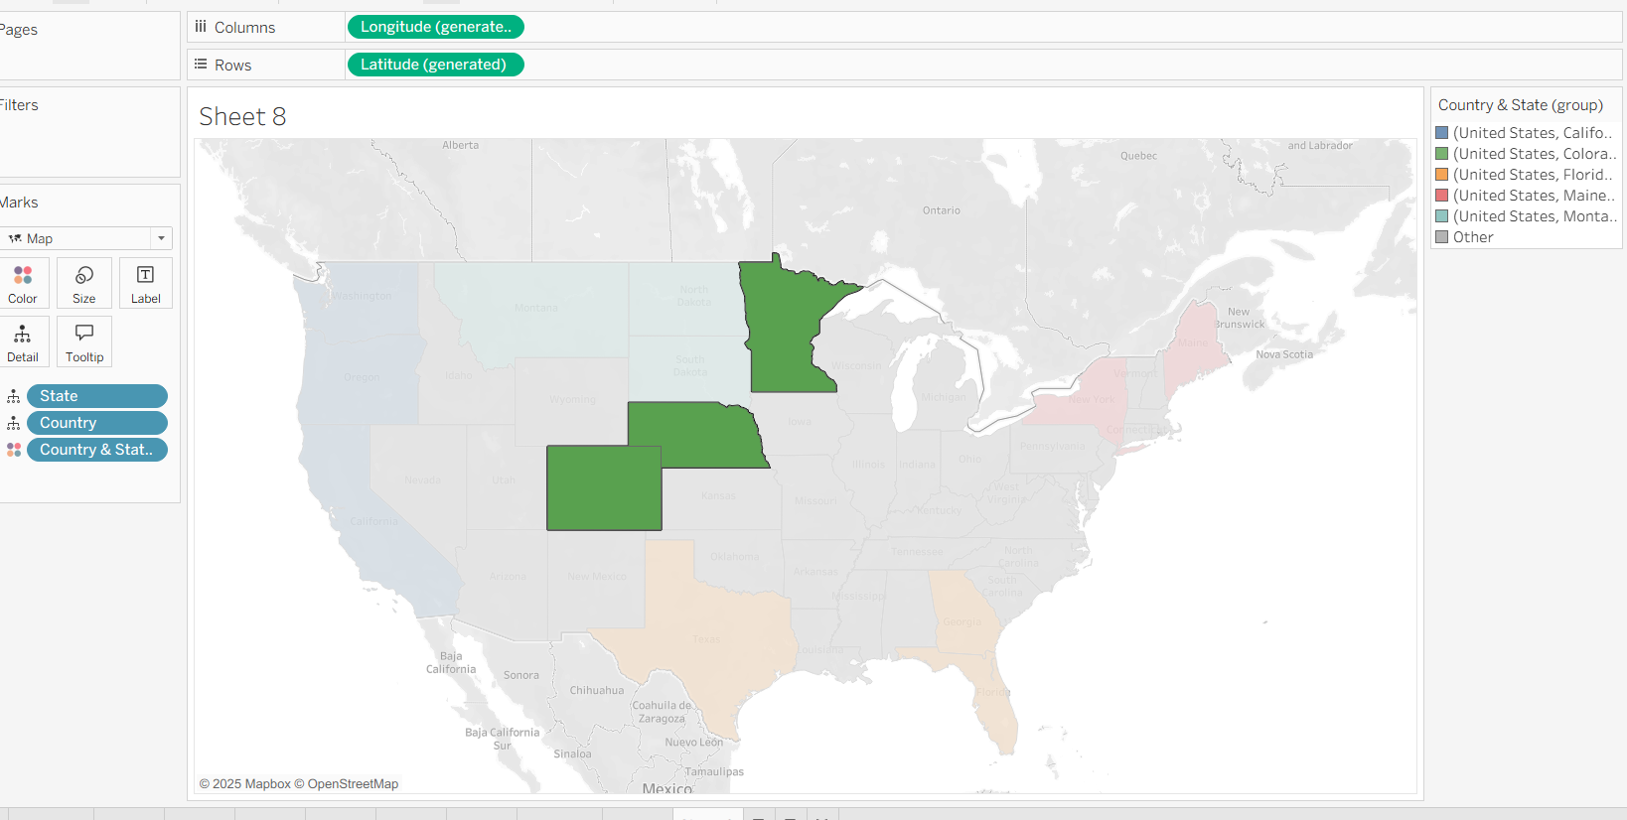

All Grouping together as per Profit

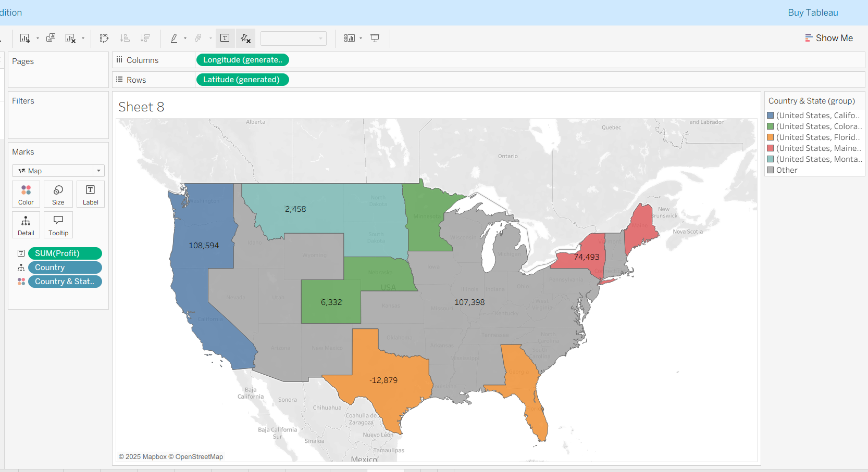

**DENSITY MAPS**

Taxi Pick up data

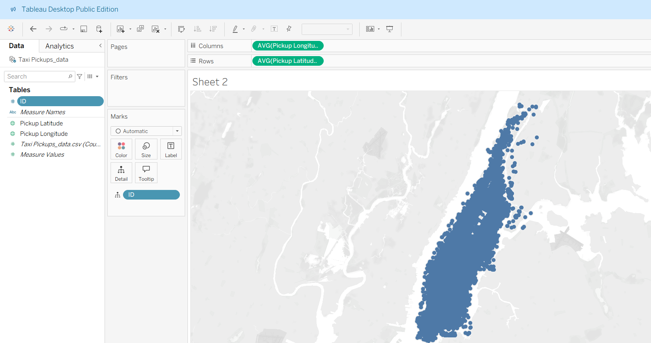

From the resulting map, it's impossible to identify any interesting trends for pickups, as there are so many overlapping marks.

Now choosing DENSITY from cards

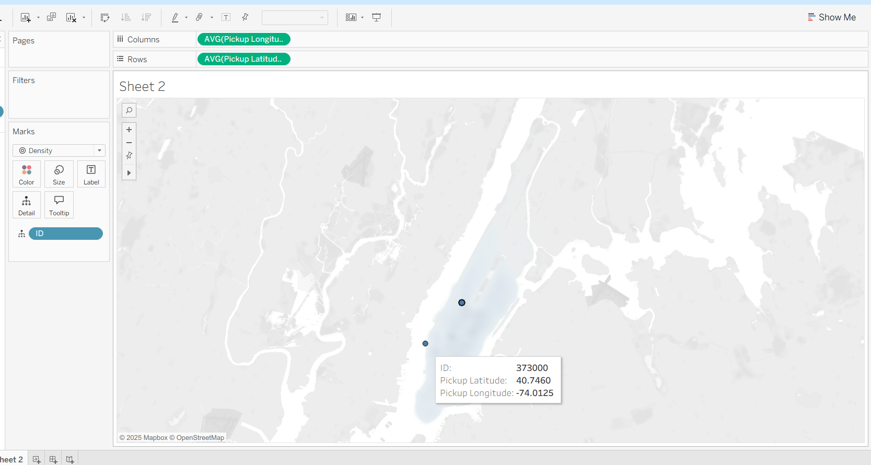

Super store data

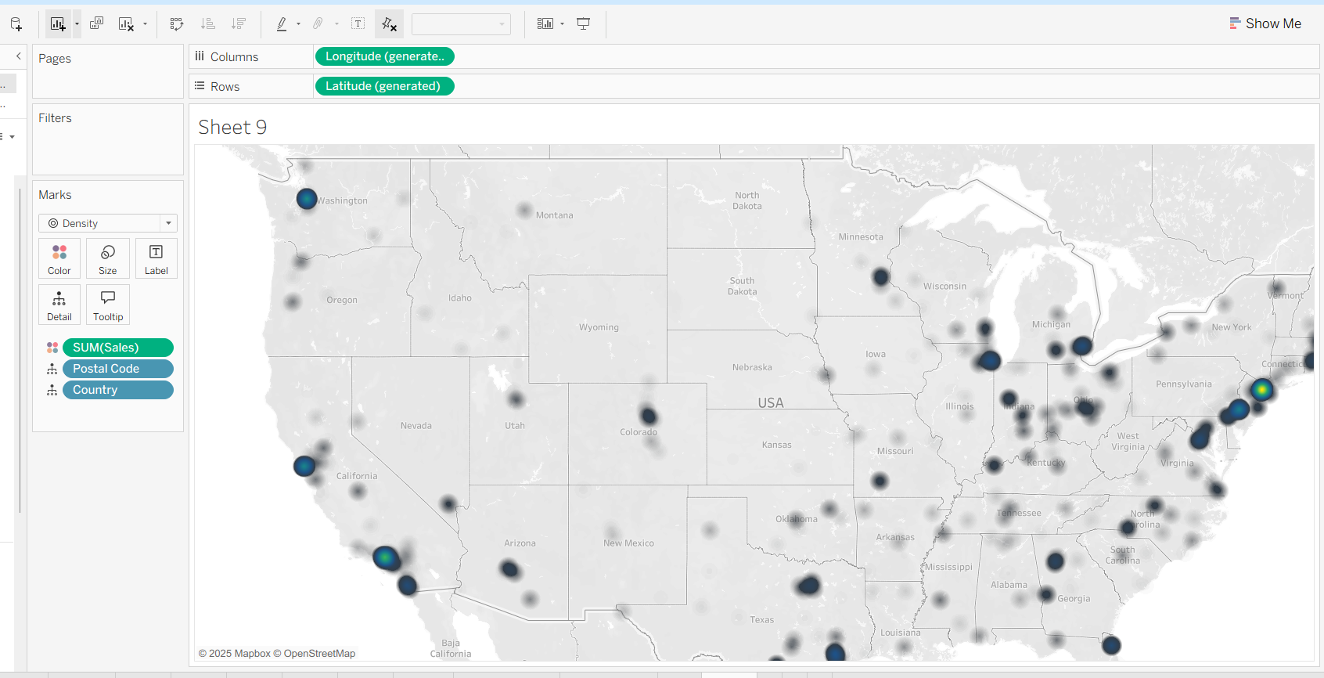

**Dual-axis mapping**

**Dual-axis mapping** is the act of stacking two maps on top of each other to share more information. For example, the following image is a dual-axis map that shows your company's *Regions*along with the *Number of Records* per city. This gives the audience a quick view of the high performing cities within each *Region*.

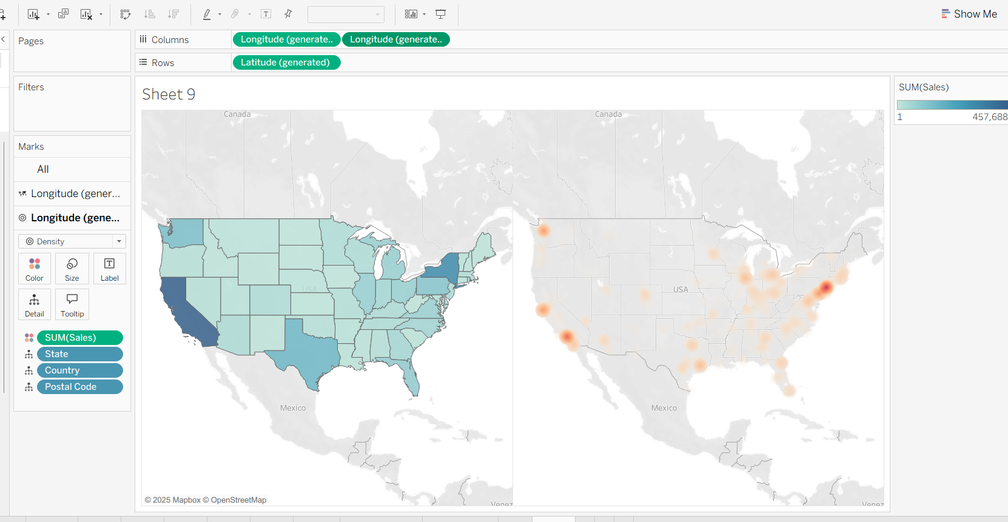

Dual axis view

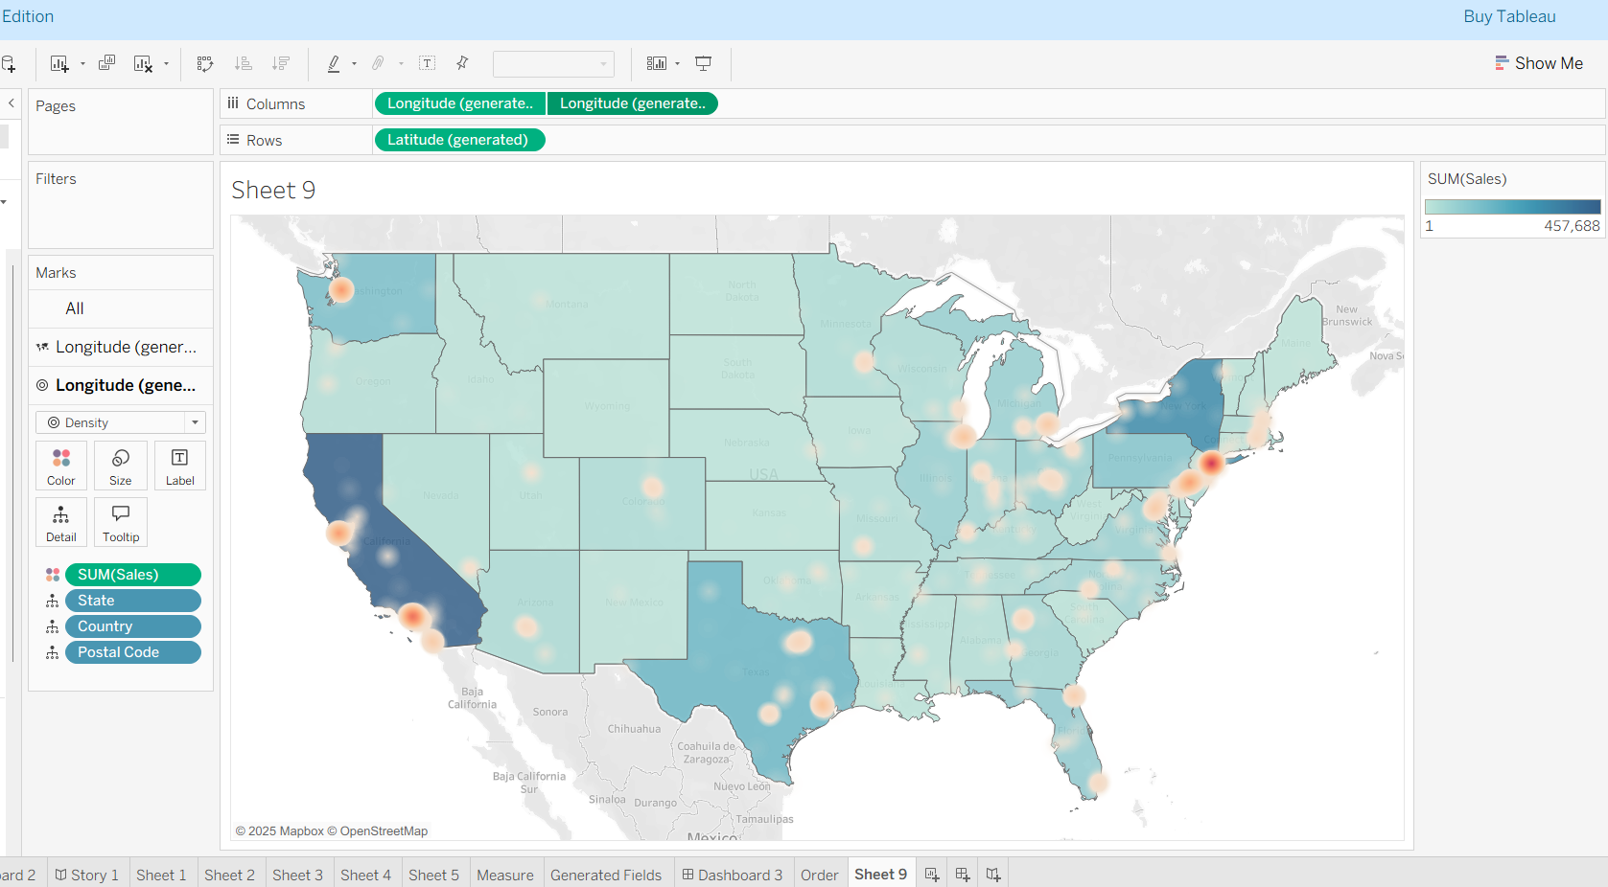

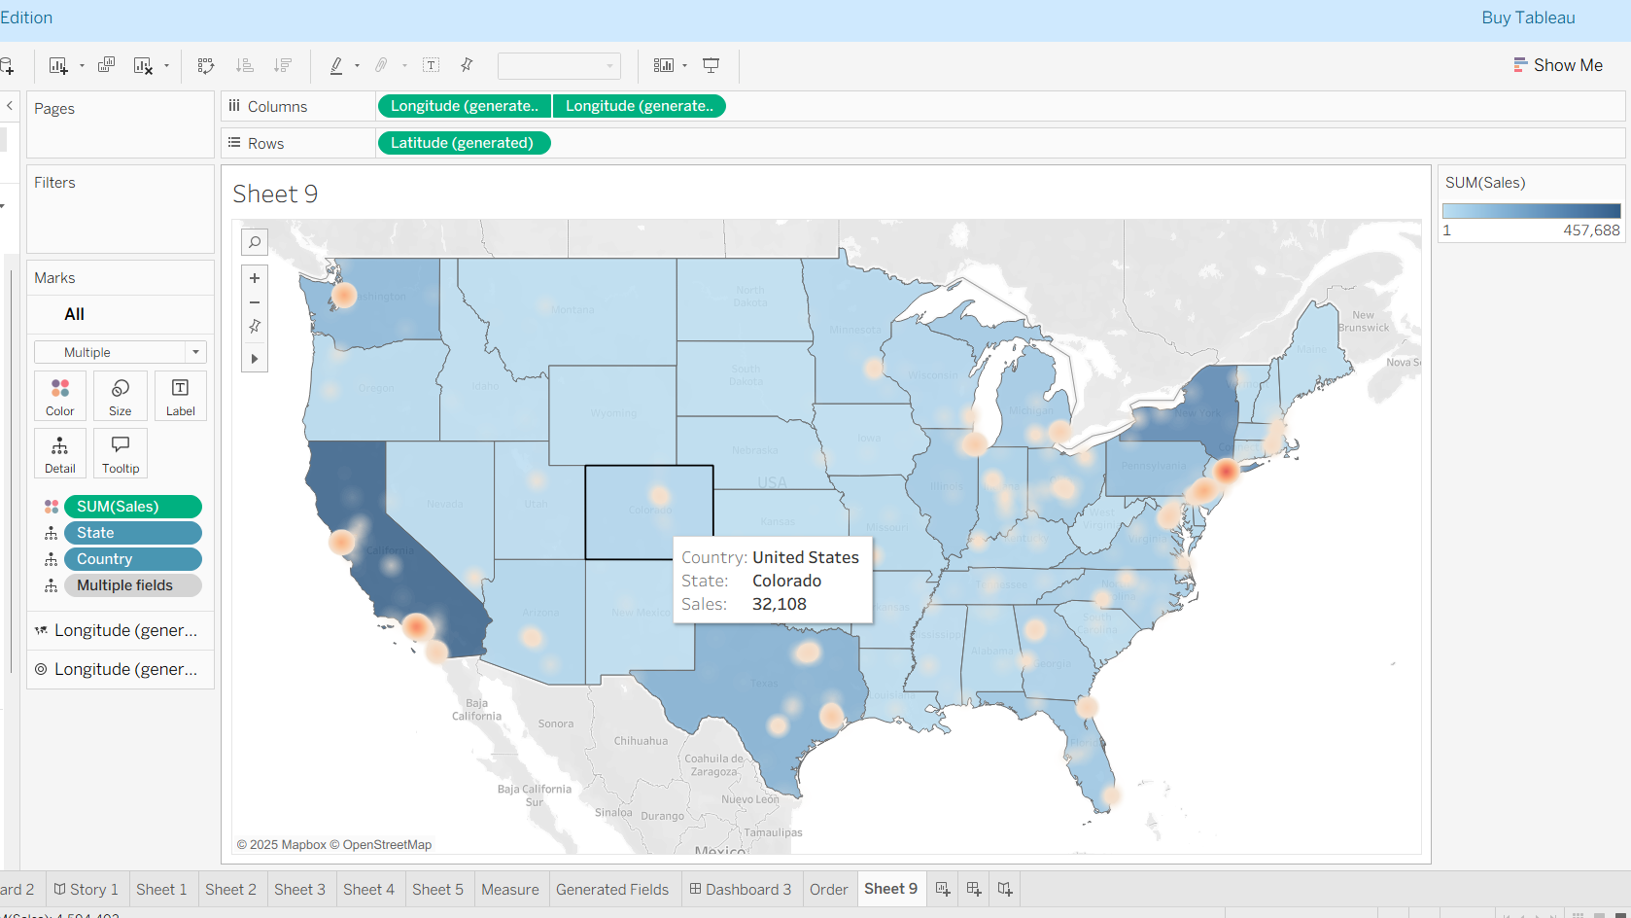

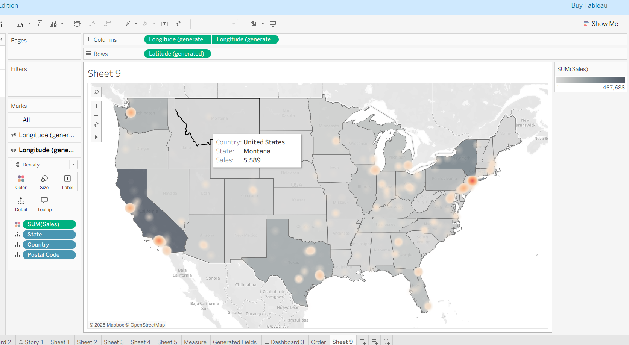

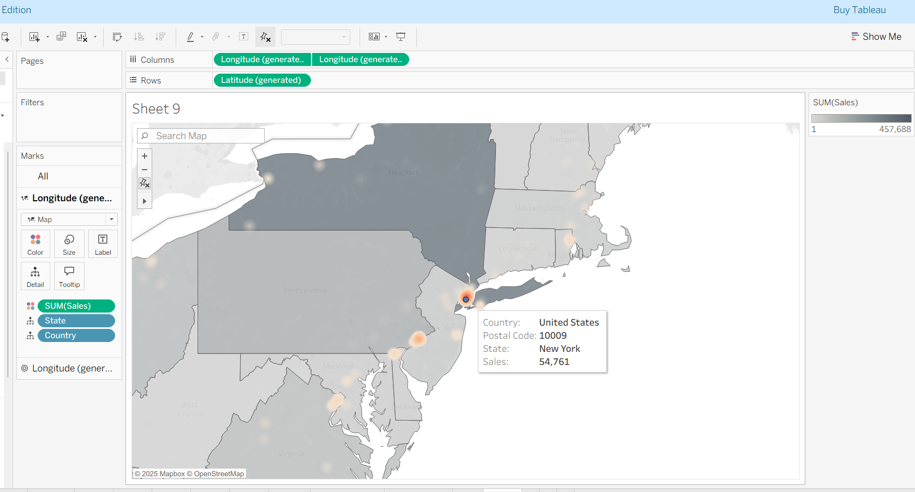

We can zoom it and see the largest sales in the state